ET-3206 DD LABORATORY

JOURNAL
EXPERIMENT - 1

Symmetric CMOS Inverter

Group No.: - ET-B3 G9

Group Members

1. Raghavi Narayanan(12311308)

Objectives:

- To design a symmetric CMOS inverter with properly sized PMOS and NMOS transistors.
- To perform DC analysis and obtain the Voltage Transfer Characteristic (VTC) of the CMOS inverter.
(c) To understand the effect of sizing on VTC.

EDA Tool used: Cadence Virtuoso – Schematic, Symbol creation, Testbench design and Simulation (ADE L).
CMOS Inverter
- A CMOS inverter consists of one nMOS and one pMOS transistor.
- The pMOS transistor acts as the pull-up network. The source of the pMOS transistor is connected to VDD, the gate is connected to input (Vin) and the drain is connected to output (Vout).
- The nMOS transistor is the pull-down network. The source of the nMOS transistor is connected to GND, the gate is connected to input (Vin) and the drain is connected to output (Vout).
- The inverter performs the basic NOT operation. When the input is 0, the nMOS transistor is OFF whereas the pMOS transistor is ON. Thus, the output is pulled up to 1. Conversely, when the input is 1, the nMOS transistor is ON, the pMOS is OFF and the output is pulled down to 0.
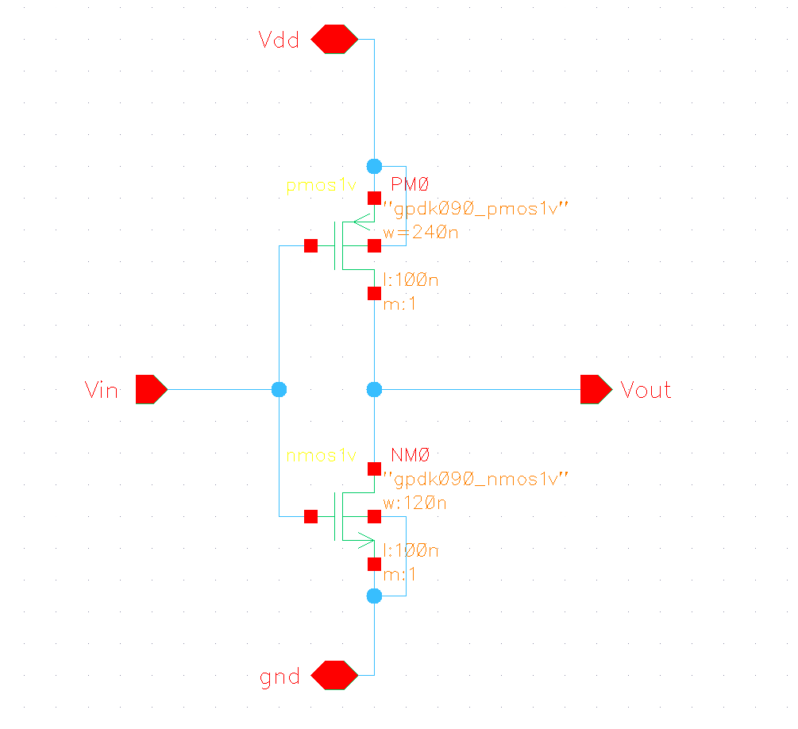
Figure 1. CMOS inverter schematic
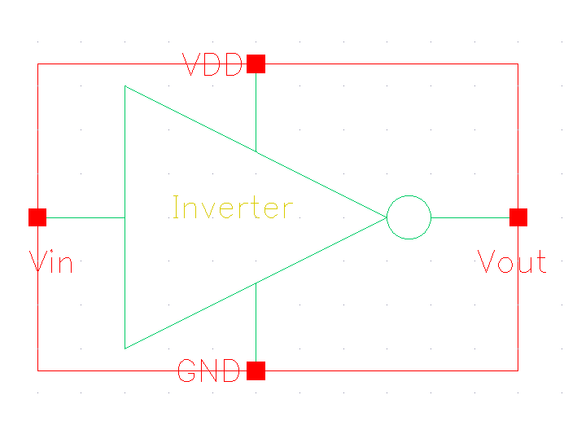
Figure 2. CMOS Inverter Symbol
In the implemented design, the width of the pMOS transistor is 240nm, while the width of the nMOS transistor is 120 nm. Both have the same length equal to 100nm.
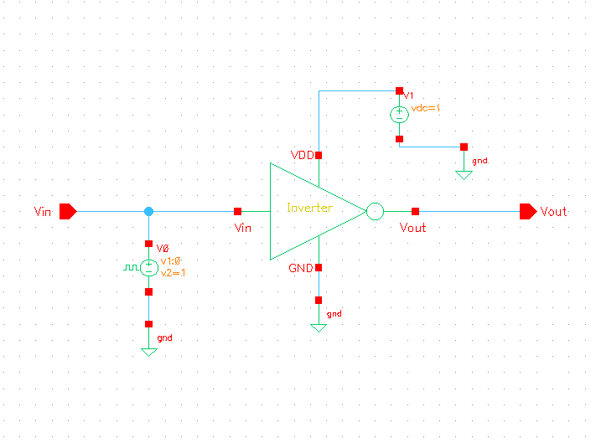
Figure 3. Inverter Testbench
This testbench is used to perform DC Analysis (VTC) and Transient Analysis.
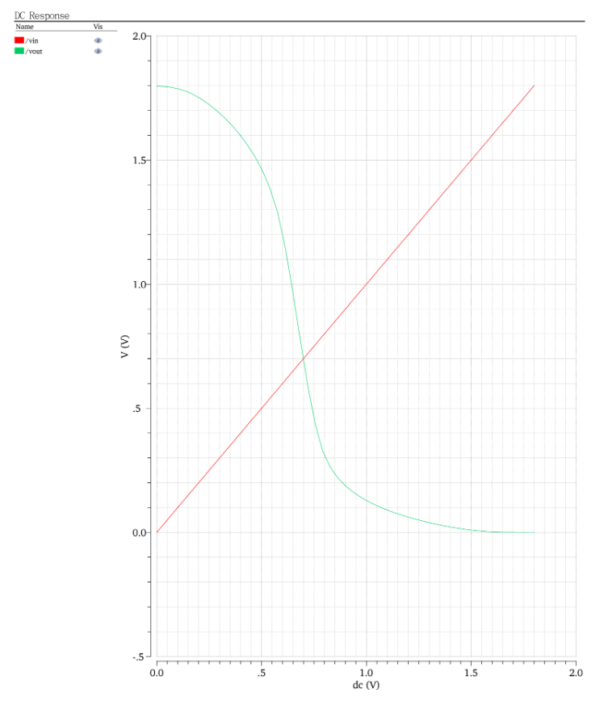
Figure 4. DC Analysis
The DC response plot shows two curves - the green curve showing Vout vs Vin and the red curve showing Vin vs Vin. The green curve shows the voltage transfer characteristic. At Vin = 0V, Vout $≈$ 1.8V (nMOS is OFF, pMOS is ON). At Vin = 1.8V, Vout $≈$ 0V (pMOS is OFF, nMOS is ON). In the transition region (0.5V to 1.0V) both the transistors are in the saturation region. Maximum current flow occurs here. The red line represents the ideal case when output equals input. The intersection with the VTC curve gives us the switching threshold (VM) which is 0.9V approximately. This switching threshold is very close to VDD/2, which is an indicator of symmetric design.
The noise margins can be calculated as follows ( -
VOH ≈ 1.8 V (when Vin = 0, output high)
VOL ≈ 0 V (when Vin = 1.8 V, output low)
VM ≈ 0.7 V
(switching threshold from VTC)For a symmetric CMOS inverter, the input low/high thresholds roughly satisfy:
VIL ≈ VM – (some small Δ)
VIH ≈ VM + (some small Δ)
(Wp = 240 nm, Wn = 120 nm), Δ ≈ 0.2–0.25 V.
- VIL ≈ 0.7 V
- VIH ≈ 1.1 V
NML = VIL - VOL = 0.7 - 0 =0.7
NMH = VOH – VIH =1.8 - 1.1 =0.7
Both noise margins are equal because the inverter is symmetric.
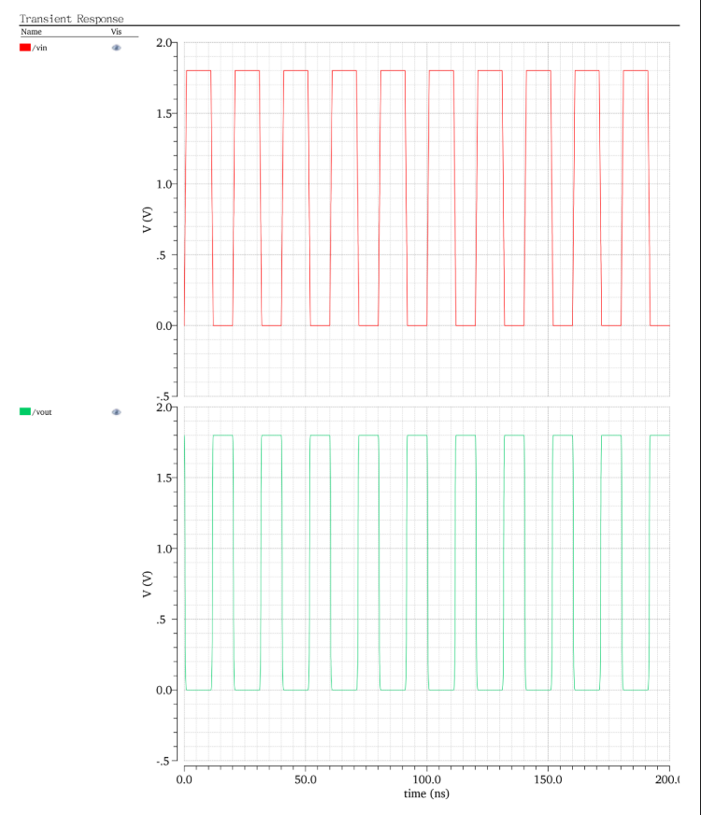
Figure 5. Transient Analysis of CMOS inverter
The transient analysis shows the inverter’s time-domain behavior with a pulse train input. The input waveform is the square pulses switching between 0V and 1.8V with a period of 20ns. The output waveform is the inverted pulses (HIGH when input is LOW and vice versa). We understand from the transient analysis that the average propagation delay is about 2.5ps. The rise and fall times are equal which confirms a symmetric design.
Observations:

- The CMOS inverter shows a clean VTC with a switching threshold of approximately 0.7 V, very close to VDD/2, confirming symmetric sizing.
- The DC analysis verifies that the output transitions sharply between logic levels, indicating proper noise margins.
- In the transient simulation, the inverter output faithfully follows the input with an average propagation delay of ≈2.5 ps, showing fast switching performance.
- Rise and fall times are nearly equal because the PMOS and NMOS were sized for symmetry

Conclusions:

In this experiment, we designed and simulated a symmetric CMOS inverter using Cadence Virtuoso. By choosing the pMOS width twice the nMOS width, we ensured a balanced design. From the DC analysis, we obtained the VTC curve and found the switching threshold to be around 0.9 V, which is roughly half of the supply voltage. This shows that the inverter switches properly and has good noise margins.
The transient analysis confirmed correct inverter behavior — the output goes high when the input is low and vice-versa. The rise and fall times were almost equal, which means the design is symmetric and efficient. Overall, this experiment helped us understand how CMOS inverter sizing affects performance, timing, and overall reliability.

